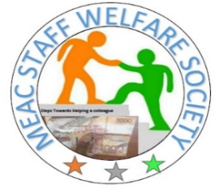
MEAC STAFF WELFARE
Cooperative Bank House, Haile Selassie Ave.
P.O. Box 8846-00100
NAIROBI Date: 30th October, 2023

NOTICE OF THE MEAC STAFF WELFARE ANNUAL GENERAL MEETING (AGM) 2023

Notice is hereby given that the Ninth AGM of MEAC Staff Welfare will be held on Thursday 30th November, 2023 at the 7th August Memorial Park, Co-operative Bank House grounds, Nairobi, starting at 9.00 a.m.

The Agenda will be as follows:

1. Adoption of the Agenda
2. Confirmation of the minutes of the AGM held in October 2023
3. Matters arising thereof from the minutes
4. Chairman’s Report
5. Presentation of Auditor’s Report
6. Treasurer’s proposed budget
7. Elections
8. AOB

By Order of the Management Committee.

Signed by :

Agnes W. Mkala,
Hon. Secretary

